Harshil Nuwal is the Managing Director of our Company. He holds a bachelor’s degree in commerce from the University of Mumbai. He is also a director in our Subsidiary and has an experience of over 14 years in the textile industry. He has been and is associated with Sona Processors (India) Limited in the capacity as a director since January 2011. He has been associated with our Company since its incorporation and has played a key role in formulating our business strategy, operational framework, and long-term vision. He is responsible for the overall management of the Company, including strategic planning, business development, procurement and operations.

Subhash Chandra Nuwal is our Chairman, Non-Executive & Non-independent director of our Company. He holds a bachelor’s degree in commerce from the University of Rajasthan. He has been associated with our Company since incorporation. He possesses over 32 years of experience in the textile industry in which our Company operates. He has been and is associated with Sona Processors (India) Limited in the capacity of a director since 1993. With over three decades of industry experience, his strategic oversight, deep industry knowledge, and business acumen have played a significant role in guiding the Company’s direction and supporting the continuity and growth of our operations.

Uma Nuwal is the Whole-time Director of our Company. She has passed the examination for a bachelor’s degree in commerce from the University of Rajasthan. She has been associated with our Company since incorporation She was previously associated with Sona Processors (India) Limited in the capacity of a director since 1995. Further she is associated with Sona Texfab Private Limited as director since 2012. She has over 26 years of experience in administrative functions and is responsible for oversight of administrative decisions pertaining to affairs of our Company, including supervision over our Company’s functions and corporate social responsibility related matters.

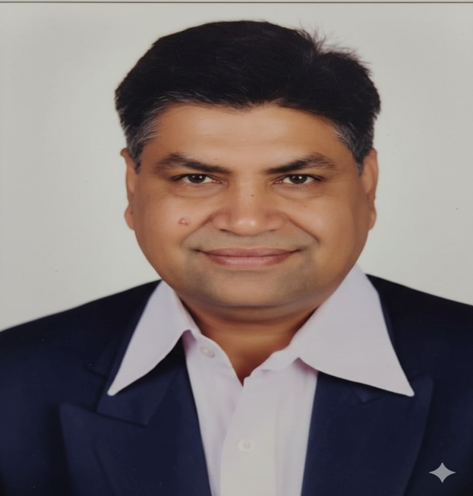

Kamlesh Kumar Choudhary is a Non-Executive & Independent Director of our Company. He holds a bachelor's degree in commerce from University of Rajasthan and master’s degree in commerce from University of Rajasthan. Additionally, he is an associate of the Indian Institute of Bankers. He has been previously associated with Bank of Baroda and retired as General Manager. He has over 39 years of experience in banking and finance sector.

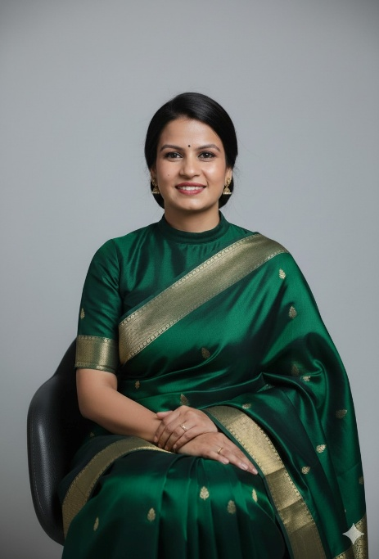

Aditi Kakhani is a Non-Executive & Independent Director of our Company. She holds a bachelor’s degree in commerce from Maharshi Dayanand Saraswati University, Ajmer, and a master’s degree in commerce from Maharshi Dayanand Saraswati University, Ajmer. Additionally, she is an associate member of the Institute of Company Secretaries of India. She is associated with Janki Corp Limited as an Independent Director and has experience of over 5 years in corporate governance and compliance.

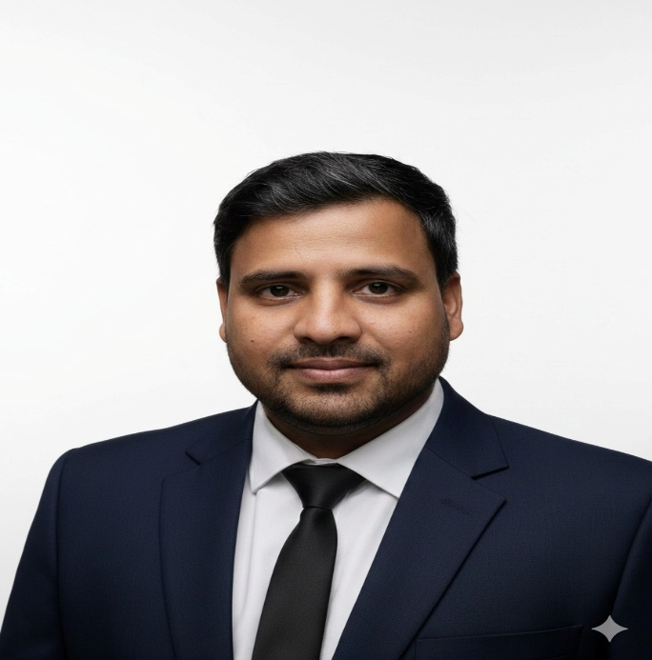

Kanhaiya Lal Acharya is a Non-Executive & Independent Director of our Company. He holds a bachelor’s degree in commerce from Maharshi Dayanand Saraswati University Ajmer, and bachelor’s degree in law from Maharshi Dayanand Saraswati University, Ajmer. He has been previously associated with Krishana Phoschem Limited as a statutory and compliance officer and also served as an independent director in Sona Processors (India) Limited and Janki Corp Limited. He has over 7 years of experience in the field of law, commerce and corporate governance.
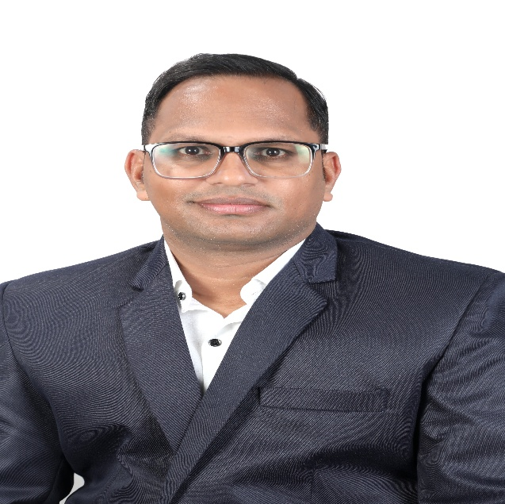

Ramesh Chandra Vyas
Ramesh Chandra Vyas is the Chief Financial Officer of our Company. He has been associated with our Company since September 01, 2022 as accounts manager and was thereafter re-designated as Chief Financial Officer on February 03, 2025. He holds a master’s degree in commerce from Maharshi Dayanand Saraswati University, Ajmer. Additionally, he is an associate member of Institute of Chartered Accountants of India. He has 7 years of experience in the finance sector. He was previously associated with Manomy Tex India Limited, as the Head of Accounts department. He is responsible for accounting, taxation and auditing. In Fiscal 2026, he received a remuneration of ₹0.63 million.
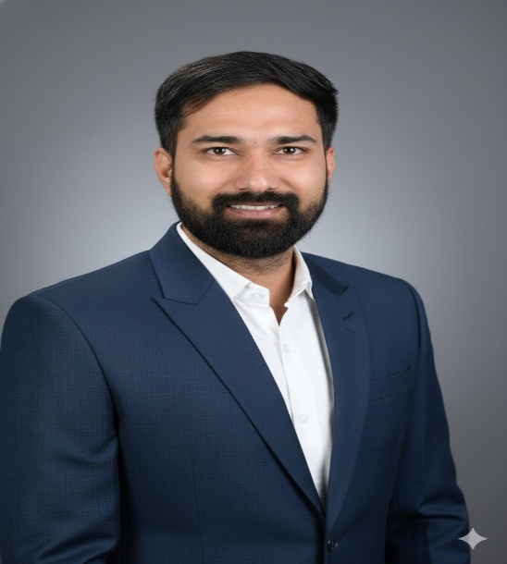
Harish Sharma
Harish Sharma is the Company Secretary and Compliance Officer of our Company. He has been associated with our Company since October 20, 2024. He holds a bachelor’s degree in business administration from Maharshi Dayanand Saraswati University, Ajmer and a master’s degree in commerce from Maharshi Dayanand Saraswati University, Ajmer. Additionally, he is an associate member of the Institute of Company Secretaries of India. He has approximately 3 years of experience in compliance and secretarial matters. He was previously associated as Company Secretary with Sudiva Spinners Private Limited, Bhilwara. He is responsible for secretarial compliance, corporate compliance, planning and handling of regulatory matters. In Fiscal 2026, he received a remuneration of ₹0.79 million.

